

Sri Lanka Institute of Information Technology

**OSGI Assignment 1 Project Report**

Software Architecture (SA)-SE3030

Submitted by:

1. IT17016230– Saranga S.A.G.
2. IT17006880– De Silva N.
3. IT17012966– L.S. Jayasinghe
4. IT17410250– M.V Lakshitha

Submitted to:

(Supervisor’s signature)

…………………………..

Name of the supervisor

31/03/2019

Date of submission

1. Description

A simple unit convertor to convert metrics and measurements such as length, weight, time and temperature, developed using Micro Kernel Architecture and deployed on Eclipse Equinox. This project consists of four publishers for each of the four metrics mentioned above and a subscriber which makes use of the publisher implementations to get the desired output. This project also makes use of Java Swing technologies in order to develop a simple UI so that the user can interact with the program more easily and in more a user-friendly manner.

1. Diagram

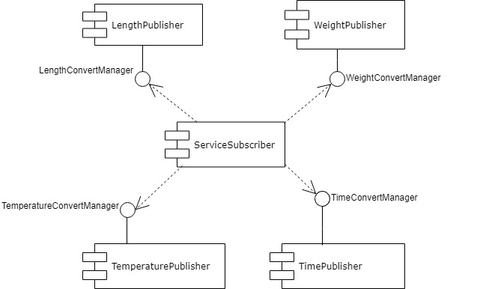

1. Imported Service and Exported Services

Exported Service packages by each bundle

* LengthPublisher-lengthpublisher
* WeightPublisher-weightpublisher
* TimePublisher-timepublisher
* TemperaturePublisher-temperaturepublisher

Imported Service packages by each plugin

* ServiceSubscriber - lengthpublisher
* weightpublisher
* timepublisher
* temperaturepublisher

1. Commands used to install and run

* create separate run configurations for each bundle (4 publishers and subscriber) by selecting Run As => Run Configurations
* start the service publishers run by right clicking the manifest file and selecting Run As => OSGi Framework
* once all are started, in the console type ‘lb’. This displays the list of bundles that are currently available.
* using the find tool (Ctrl +F) in the console find the 4 publishers and subscriber by searching for their bundle name and obtain their corresponding bundle id
* type ‘start <bundle id>’ to start a required bundle or ‘stop <bundle id>’ to stop a required bundle.

1. Sample Screenshots